Julian Amberg
BANA 607 | Business Analytics
10/10/2024

BANA 607 Midterm 1
Introduction: Description of Variables
- Column: "age"
  - Description: Age of the individual in years.
  - Type: Numerical
- Column: "salary"
  - Description: The amount of money individuals in the sample earns per year.
  - Type: Numerical
- Column: "gender"
  - Description: The preferred gender of the individual.
  - Type: Categorical
  - Categories: ['Male' 'Female']
- Column: "smoking_habit"
  - Description: Identifies what type of smoking habits, if any, an individual in the sample might have.
  - Type: Categorical
  - Categories: ['Heavy Smoker' 'Light Smoker' 'Non-Smoker']
- Column: "work_out_habit"
  - Description: Identifies what type of workout habits an individual in the sample might have.
  - Type: Categorical
  - Categories: ['None' 'Occasionally' 'Regularly']
- Column: "heart_attack"
  - Description: Identifies whether or not an individual in the sample has had a heart attack.
  - Type: Categorical to Numerical, aka dummy variable (Boolean value)
  - Categories: [‘0’, ‘1’]
- Column: "education"
  - Description: Identifies the highest level of education an individual in the sample.
  - Type: Categorical
  - Categories: ["Bachelor's" 'High School' "Master's" 'PhD']
Initial Findings
Descriptive statistics for 'age': | Descriptive statistics for 'salary':
count 180.000000 | count 181.000000
mean 51.388889 | mean 93070.790055
std 14.200633 | std 45858.491116
min 23.000000 | min 23747.000000
25% 43.000000 | 25% 64073.000000
50% 51.000000 | 50% 87481.000000
75% 56.000000 | 75% 106173.000000
max 130.000000 | max 400000.000000
Name: age, dtype: float64 | Name: salary, dtype: float64
Mode of 'age': 53.0 | Mode of 'salary': 23747.0
Skewness of 'age': 2.388807966577785 | Skewness of 'salary': 3.410982679475538
Kurtosis of 'age': 9.828722788426603 | Kurtosis of 'salary': 17.923455394604954
Percentiles for 'age': 0.01 30.0 | Percentiles for 'salary': 0.01 33883.6
0.10 37.0 | 0.10 55990.0
0.25 43.0 | 0.25 64073.0
0.75 56.0 | 0.75 106173.0
0.90 65.0 | 0.90 131515.0
0.99 112.1 | 0.99 310000.0
Name: age, dtype: float64 | Name: salary, dtype: float64
IQR (Interquartile Range) of 'age': 13.0 | IQR (Interquartile Range) of 'salary': 42100.0

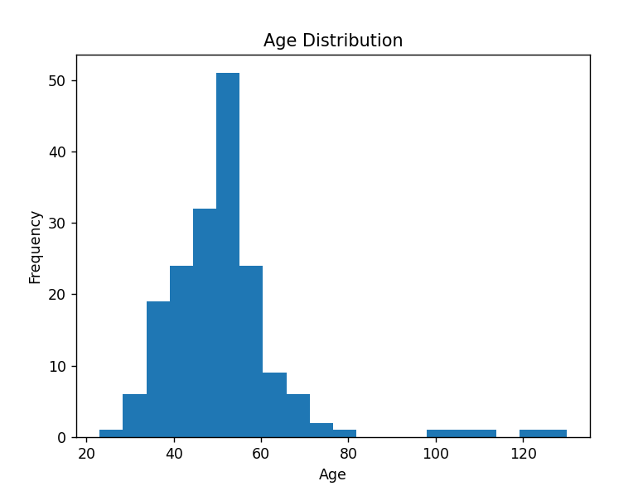
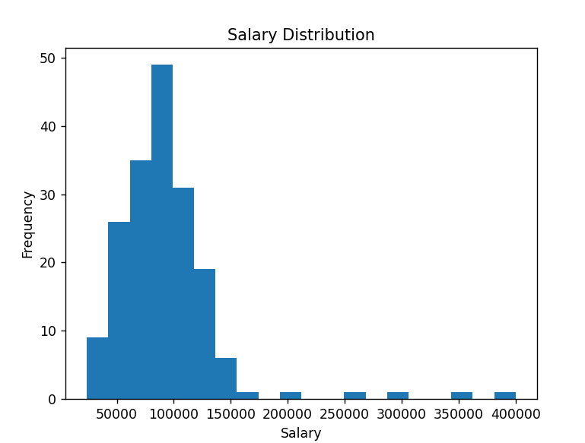
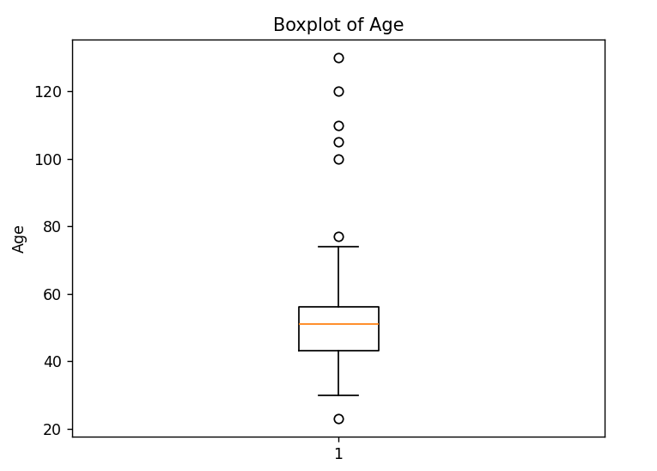
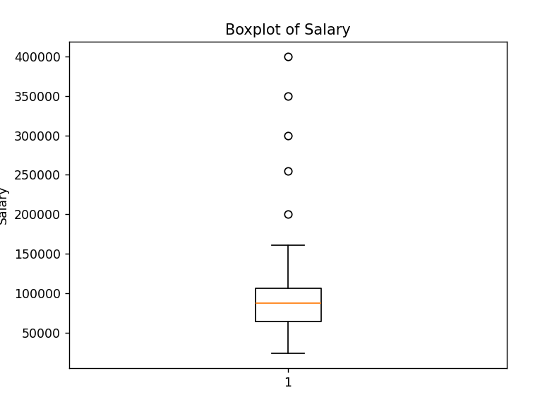
Numerical Initial Analysis
Both numerical data variables appear to have significant outliers with a significant positive skew. While the skewed trend is expected, especially for salary, the values of the skew and the kurtosis are well beyond the margins. Not to mention, the noticeable outliers seen in the plots above.

Frequency distribution for 'gender':
gender
Female 104
Male 96
Relative frequency distribution for 'gender':
gender
Female 0.52
Male 0.4
Frequency distribution for 'work_out_habit':
work_out_habit
Occasionally 70
Regularly 37
Relative frequency distribution for 'work_out_habit':
work_out_habit
Occasionally 0.654206
Regularly 0.34579
Frequency distribution for 'smoking_habit':
smoking_habit
Non-Smoker 122
Light Smoker 54
Heavy Smoker 24
Relative frequency distribution for 'smoking_habit':
-----smoking_habit
Non-Smoker 0.61
Light Smoker 0.27
Heavy Smoker 0.12
Frequency distribution for 'education':
education
Bachelor's 105
Master's 45
High School 37
PhD 13
Relative frequency distribution for 'education':
Education
Bachelor's 0.525
Master's 0.225
High School 0.185
PhD 0.065

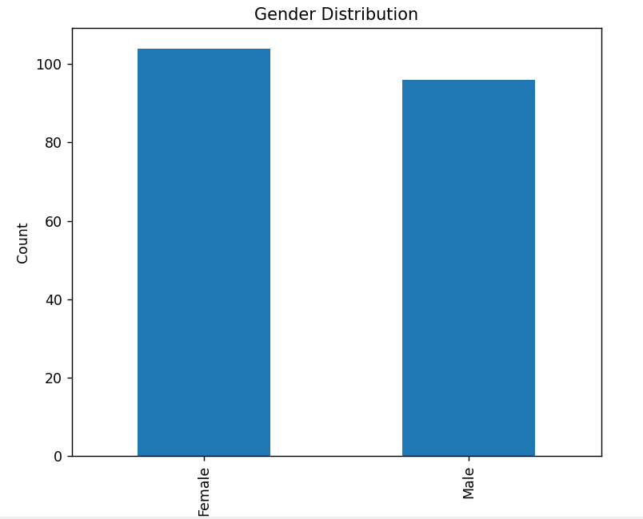
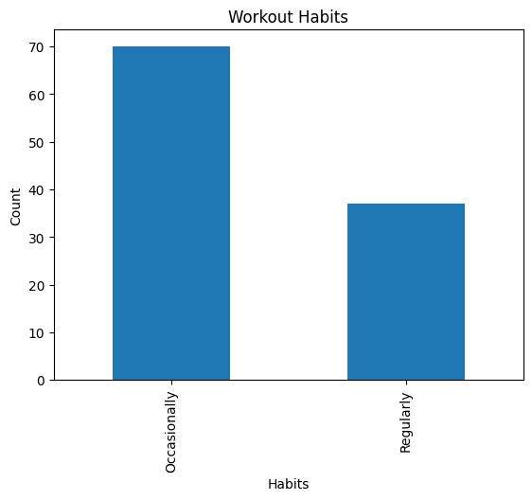
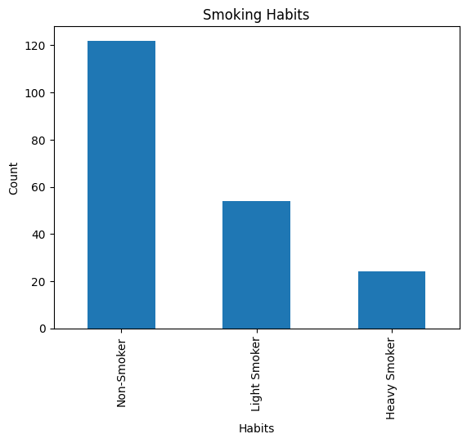
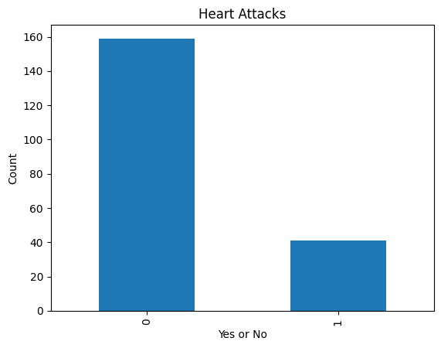
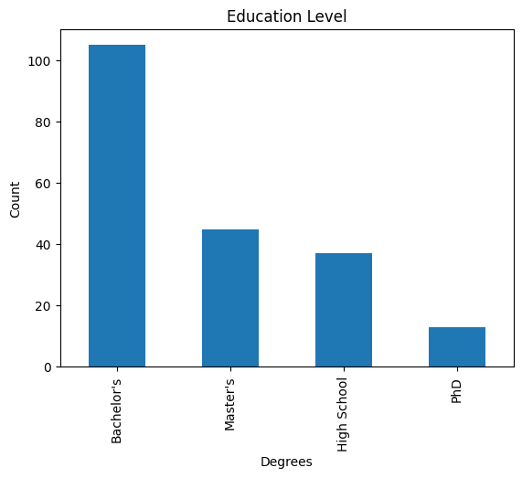
Categorical Initial Analysis
All the plots and the general distribution appear to look accurate, however there is one variable with issues. The ‘work_out_habit’ column whose values include None, Occasionally, and Regularly. In both the distribution analysis and the plots, the None value data is missing which suggests values are missing.
Adjusting Missing Data Values and Outliers
Numerical
Since the missing values within the numerical data are skewed, we must use the median as it will be more consistent and more reliable than the mean which is dependent on all values (including the outliers which will skew the distribution further).
The outliers will be addressed by providing bounds created by the Inter-Quartile Range x 1.5 +- Q3 and Q1 respectively. Once the bounds are set, the outliers rows will be removed which will create a more normal distribution.
Categorical
The missing values within the ‘work_out_habit’ column can be left as nan because they also correspond with None.
Post-Cleaning Findings
Descriptive statistics for 'age' after cleaning:
count 190.000000
mean 49.405263
std 8.283277
min 30.000000
25% 44.000000
50% 51.000000
75% 54.000000
max 69.000000
Name: age, dtype: float64
Skewness of 'age' after cleaning: -0.11905478989522286
Kurtosis of 'age' after cleaning: -0.0880670876519174

Descriptive statistics for 'salary' after cleaning:
count 190.000000
mean 93132.673684
std 44409.949610
min 23747.000000
25% 67595.250000
50% 87481.000000
75% 104354.000000
max 400000.000000
Name: salary, dtype: float64
Skewness of 'salary' after cleaning: 3.5777343925594836
Kurtosis of 'salary' after cleaning: 19.595117206917237

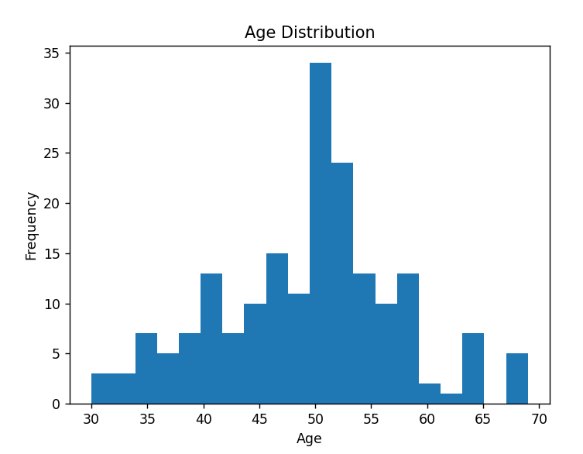
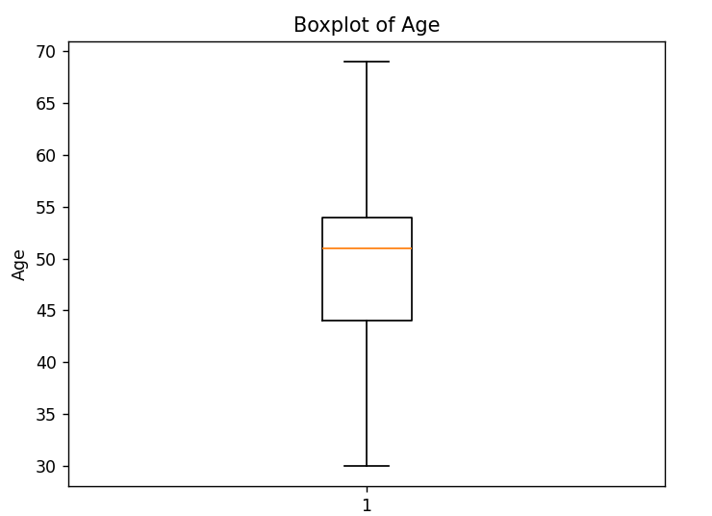

Removing outliers and adding the median to the missing values has transformed the data to normalized distribution.
The Mean and Standard Deviation have shifted lower than before and the median has stayed the same.

